Swanton Cemetery Commission Update:

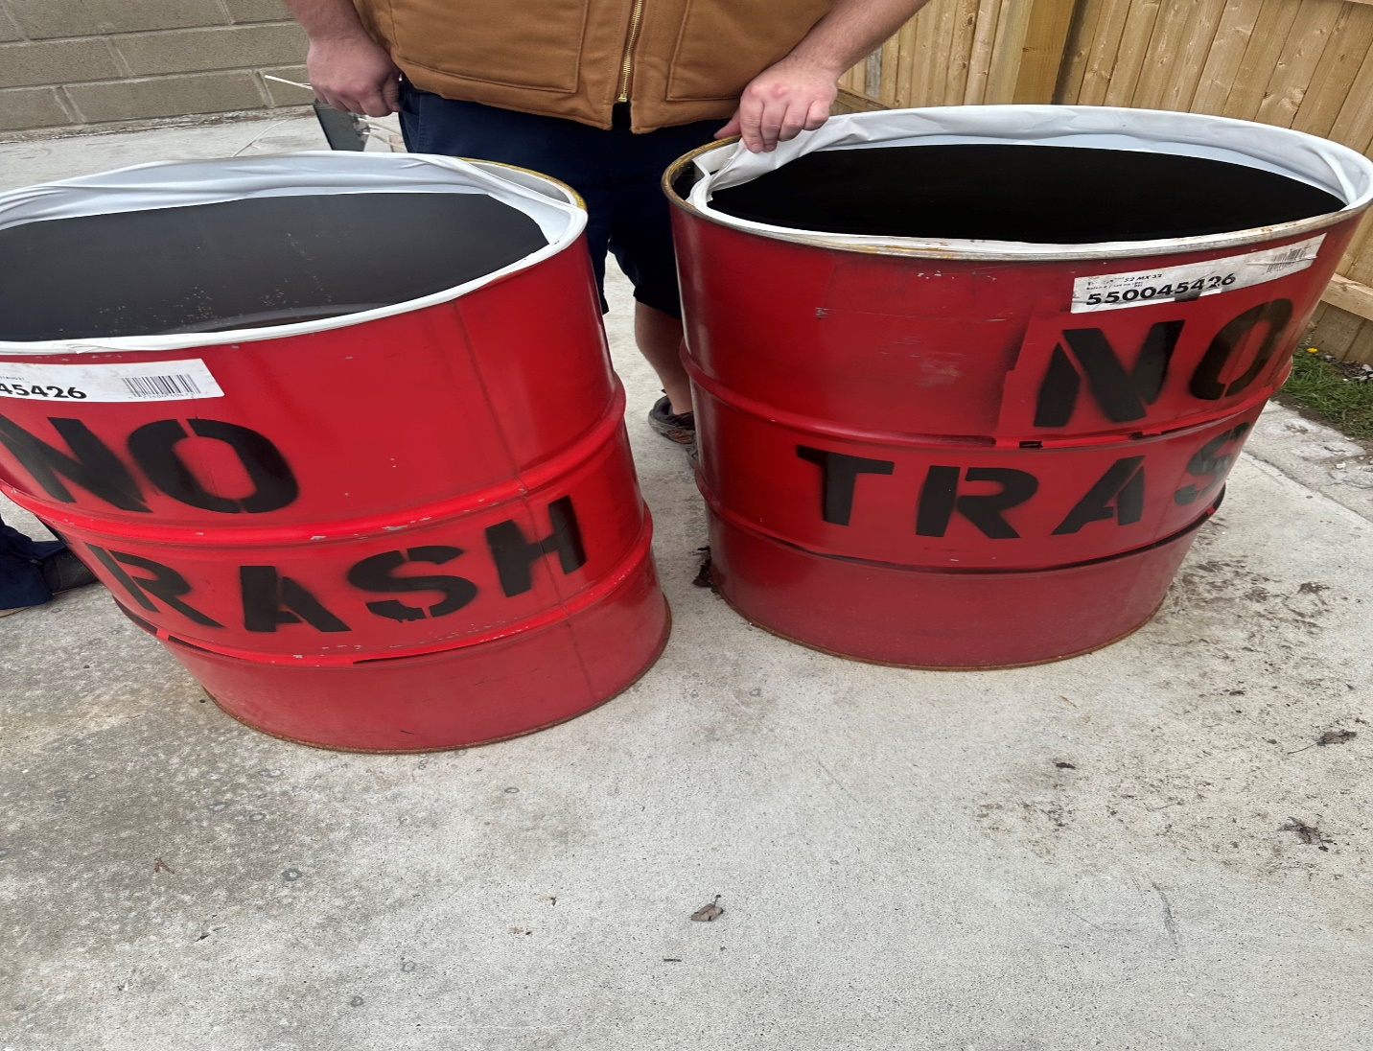
The cemetery commission is excited to announce the addition of two new barrels for flower debris at Riverside.
Throwing debris over the bank in the back of Riverside is NOT an option as we do not own the land.
Please respect our barrels by adding ONLY flower debris, NO trash allowed. We want to keep these easy for the planting season. The barrels are located in the new fence attached to the vault.

